3rd grade Material List

- 1 three ring binder (1 ½ inch with clear pocket cover)
- 3 notebooks
- 3 folders
- 3 boxes of #2 pencils
- 1 pencil pouch
- pair of scissors
- 2 glue sticks
- personal set of earbuds
- 1 box of crayons OR colored pencils
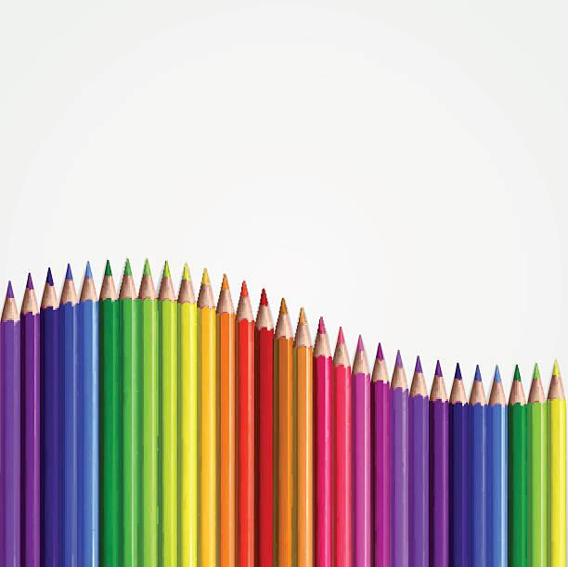
- 3 containers of Clorox wipes
- 3 boxes of tissues

